Capo 2
[Intro]
D Dsus2 Gmaj7 G6 x2
[Verse 1]
D Dsus2 Gmaj7
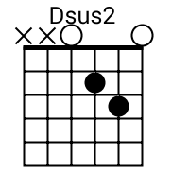
Hey, Miss Sunshine, I took a tab and felt the sky
G6 D
It's a good life, and then it's bad, but that's all right
Gmaj7
On the bright side, we all sin and sympathize
G6 D
So in the meantime, might as well enjoy the ride
Dsus2
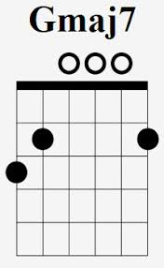
Four seats of five people 'bout to take a daytrip
Gmaj7 G6
Roll the windows, roll one up, let's make a spaceship
D Dsus2
Where's the volume? Turn it up, who got the playlist?
Gmaj7 G6
Everybody sings the song, just like we're famous
[Pre-Chorus]
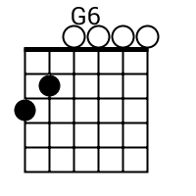
A Bm G A
We were royalty in a cheap hotel
Bm A G
Dazed and confused, but we cleaned up well
Bm A
Didn't need no help for a hell of a time

Ha-ha-ha-ha-ha-ha, yeah
[Chorus]
D G A
It's a long way home
Bm
Uh
D G A
It's a long way home
Bm
(Don't know which way to go)
D G A
It's a long way home
Bm
Mm-mm
D G A
It's a long way home
N.C.
Uh-uh
[Verse 2]
D Dsus2
These bad decisions I make, it's just me avoiding boredom
Gmaj7 G6
Call it ironic, I got money and poor decorum
D Dsus2
Feels like I'm flying off coffee and Coca, uh, ah, Cola

Gmaj7 G6
Only lights on my horizon are ones that pull me over
D Gmaj7
(Damn) I'm a drifter, let me go
D
It's the only life I know
Dsus2 Gmaj7
Chasing vultures and black crows
A
To the promised land, I'm sold

[Pre-Chorus]
Bm G A
We were royalty in a cheap hotel
Bm A G
Dazed and confused, but we cleaned up well
Bm A
Didn't need no help for a hell of a time

Ha-ha-ha-ha-ha-ha, all right
[Chorus]
D G A
It's a long way home
Bm
Uh
D G A
It's a long way home
Bm
(Don't know which way to go)
D G A
It's a long way home
Bm
Mm-mm
D G A
It's a long way home
[Outro]
D Dsus2
I got my shades on
Gmaj7 G6
Because the day's long
D Dsus2
I'm on the highway, uh
Gmaj7 G6
I got to move on

